Indefinite Numeral Adjectives

🔹 What Are Indefinite Numeral Adjectives?
# Source: AI Source: Provided by: [Data Path: Persons Table -> ID Column: 1, Name_En Column: Motasem Essam] -> From: [Chatgpt (GPT-4-turbo)] on [7/27/2025]
Indefinite numeral adjectives describe non-exact or uncertain numbers or quantities.
They tell how many, but not precisely.
They answer:
- 👉 How many? — without giving an exact number.

✅ Common Indefinite Numeral Adjectives
# Source: AI Source: Provided by: [Data Path: Persons Table -> ID Column: 1, Name_En Column: Motasem Essam] -> From: [Chatgpt (GPT-4-turbo)] on [7/27/2025]
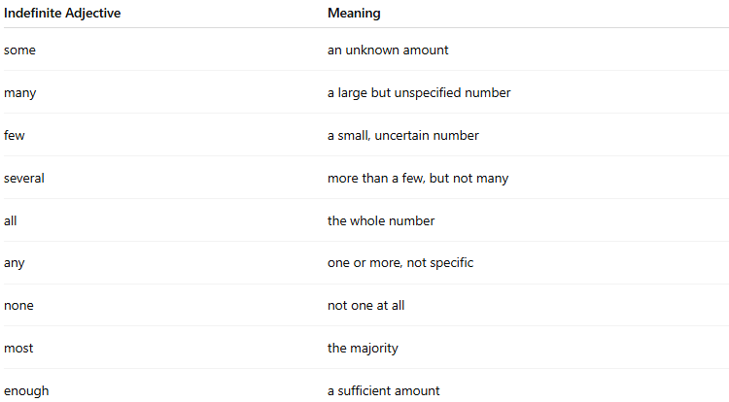
Indefinite Adjective | Meaning
some | an unknown amount
many | a large but unspecified number
few | a small, uncertain number
several | more than a few, but not many
all | the whole number
any | one or more, not specific
none | not one at all
most | the majority
enough | a sufficient amount

📚 Examples in Sentences
# Source: AI Source: Provided by: [Data Path: Persons Table -> ID Column: 1, Name_En Column: Motasem Essam] -> From: [Chatgpt (GPT-4-turbo)] on [7/27/2025]
- Many students were absent today.
- Some people prefer tea over coffee.
- We saw several birds in the park.
- Few apples are left in the basket.
- Most children love ice cream.

🧠 Key Points
# Source: AI Source: Provided by: [Data Path: Persons Table -> ID Column: 1, Name_En Column: Motasem Essam] -> From: [Chatgpt (GPT-4-turbo)] on [7/27/2025]
- Indefinite numeral adjectives do not give exact numbers.
✅ He has many ideas. (We don't know how many.)
❌ He has five ideas. (This would be definite.)
- They always come before a noun.
✅ She bought some books.
✅ We need enough chairs for everyone.

